

December 1, 2010 Issue 4

# Armenia Yerevan Mission

Dear Elders & Sisters,  
This month we remember the Savior's birth and celebrate Christmas. It's a time that brings a special Spirit in the entire Christian world and reminds us that we are part of a great body of Christian believers. While the tenets of our beliefs differ, still millions accept Jesus Christ as the Son of God.

Yesterday I was at a bridge in Georgia where scores of thousands gave their lives rather than disrespect and disclaim their faith in Christ. In 1226 an invading Pagan army came into this Christian nation with a determination to stamp out Christianity. An image of Mary and Jesus was put on the ground and the people ordered to cross the bridge and spit upon the image. Any who refused were beheaded and their bodies thrown in the river. Far more died than lived and today Georgia is still a great Christian nation.

We can be grateful that in Armenia and Georgia a belief in Christ has survived any and every attempt to crush it. Truth has prevailed and now we come to Christian nations with a fullness of that truth to help bring Heavenly Father's preserved believers unto the greater light of the restored Gospel of Jesus Christ.

Our opposition is ever present but our success is assured. Having been called here under authority of a living Prophet of God, each of you becomes part of the great Christian heritage of these two countries. You bring a message of hope and of light and of eternity. In this Christmas month especially may we proclaim it with our might in the strength of the Spirit.

With great love for each of you,  
**President & Sister Carter**

**From Sister Hallewell & Crawford**

This week I was kind of having a slump and on Friday morning I prayed to see the Lord's hand in my work.  Well, it was an amazing day because I prayed, we planned for the week, and then we went out to do a few visits. Well, the Lord gave us three unplanned visits and five new investigators. We found all of our investigators for this last week Friday afternoon!  It was an amazing day. We just kept talking to people and getting invited over and invited home with them and asked to come back and it was awesome!!!!  We loved it. It resulted in a very busy Saturday as well. :) I love this work when we are busy. :)

**From Elder Stutz & Stephenson**

A few days ago, we were in a taxi in Georgia. The man happened to be Armenian and he knew the best Armenian of anyone we have met in Georgia. We talked about the Restoration of the gospel and then about eternal families. We tried to explain to him several times that he needed to be married for eternity to be with his wife after this life. I tried hard to explain it in simple terms. Finally, that time he understood what we were saying and he said, "I am deeply interested in your words. I will go to the church and learn more from the Elders." It was a testimony to us that when we explain the gospel in terms that others understand and with the help of the spirit, their hearts will be touched.

**New Members in Armenia!**

**Ashot – Arabkir Branch**

**Ani, Armenak, Alvart, Meline, & Yura**

**Vandazor Branch**

***3rd Sister Pincock***

***6th Sister Rich***

***12th Sargis Ayvazyan***

***25th Elder Zuniga***



Dear missionaries and friends,

Tradition goes that I'm supposed to write something at the end of my mission, so first I will say -

I know that I am coming home at the right time.  Though I didn't choose the date for myself, my body and my spirit both feel that it's right. I felt for months long before I got sick that around this time was the time God wanted me to go home. I guess it just took me being sick to get me home at the right time. *amused*  God has a work for me to do with my family, this I know. I guess we'll see how well I've learned the lessons on my mission, because now it is up to me to apply them with my family and see new miracles happen.

As for lessons learned - faith, hope, charity aren't just words to throw around but are living, breathing principles that need to be lived more than known.  You can't have intellectual knowledge of faith; you can't just throw the definition around in Sunday school class and expect that definition to save you. You have to live it.  The same goes for hope and charity.

Along with living the gospel, only "a chapter a day" in the scriptures, only reading the minimum amount of time is not enough spiritual strength to get you through the day or overcome the trials that come your way.  We are told to feast on God's word, not nibble on it. One meal a day of a piece of toast never kept anyone alive; the same goes for spiritual health.

Live the gospel, don't just know it.  I made that mistake once, and that mistake almost cost me everything I held dear. That's not dramatic, that's truth.  Living the gospel is what brings joy and happiness: loving others brings you love, bringing happiness to others brings you happiness in return.  Partaking of the sacrament and Christ's sacrifice for our sins wipes away our mistakes and gives us a fresh start.  Reading the scriptures teaches us who God is and His plan for us and prayer is the means by which we can speak to Him and receive the help we need.

Like Joshua of old, fear not.  God is with us.  He has not sent us here to be tested only to leave us on our own. No, a loving father would not do that.  He loves us.  He loves me.  Everything will be all right.  "Our future is as bright as our faith."

-Sister Christensen, who probably writes too much

Elders and Sisters,

I want to refer you to a parting testimony shared with me by a respected missionary who recently returned home. I believe you’ll see the truth of his words:

“Well as I read my parents and friends emails, it was hard not to shed a few tears. I have come to love this people and it is sad that I just have to pack my bags and leave them. I have thought much about my mission these past few days and it means everything to me. I'm glad I got to be here in Armenia for 2 years and help people come unto Christ. I know I have. I entered the MTC not really knowing what I was exactly doing and now I know and have been converted to the gospel of Christ. There were many times on my mission where I didn't know what I was doing, when I thought I was wasting my time, when I couldn't learn love or have charity, when I thought about going home, but I have come to realize that I couldn't do anything on my own. When I tried to get along with a companion by myself, I failed. When I wanted to find investigators by myself, I failed. When I wanted to come to love the people by myself, I failed. The Lord was wanting me to learn. Once I started relying on the Lord to help me get along with a companion or come to love the people it worked. I feel like I have kinda figured it out. I shouldn't worry so much about those small things and just sanctify myself and be worthy for the guidance of the Holy Ghost. And then the Lord can shape it and do it his way. We just need to learn how to rely on the Lord and do it his way.

President Carter

**District Thanksgivings!**

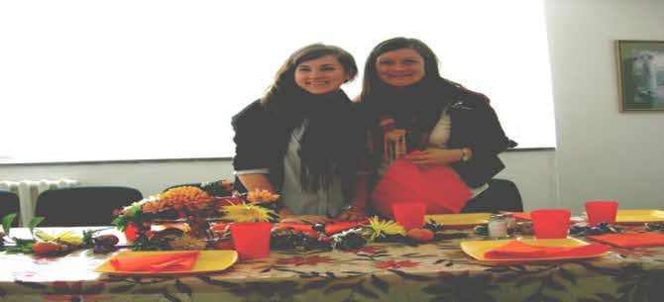

Vanadzor & Gyumri Districts

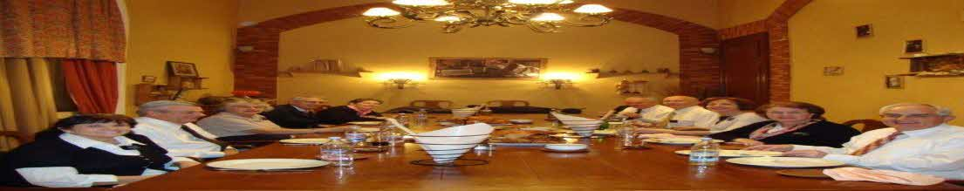

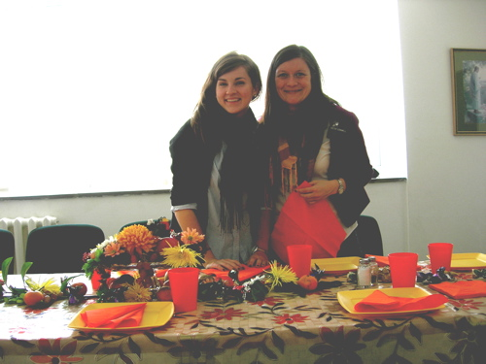

**Ajapnyak, & Charentsavan Districts**

**Zone Conference & Mission Tour**

**Center & Artashat Districts**

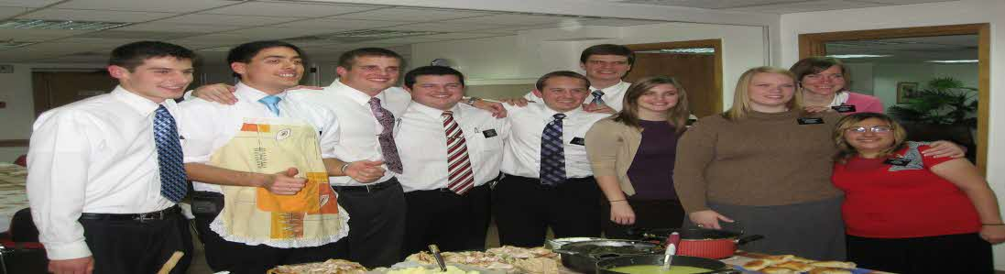

Elder Manzhos & Georgia Zone

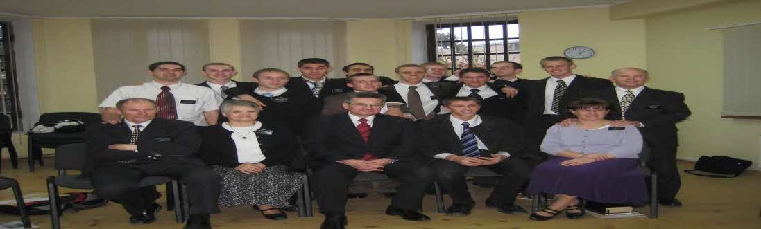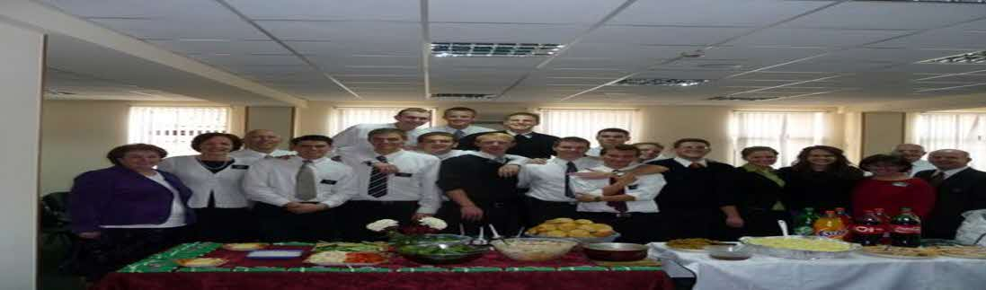

Senior’s 2nd Dinner